
60 Minute Intumescent Letterbox
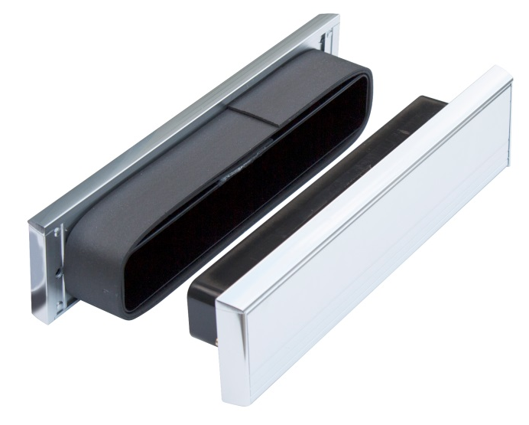
Fire Tested
Tested to BS 476 Part 22 1987, 60 minute rated

Description
A high quality robust all aluminium construction draught proof letterbox, combined with an integral intumescent liner and fitted with various types of finishes of letter flap. The letterboxes are adjustable to suit door thickness of 40mm - 80mm.

Finishes Available

12” Intumescent Letterboxes
Polished Gold
Polished Silver
Satin Anodised Aluminium (SAA)

Installation

- Carefully cut an aperture in the Fire door leaf up to 1050mm from the bottom of the door. Please ensure that the aperture is a tight fit.
- The face plate fitted with the integral draught excluders should be located to the internal face of the door.
- Locate the letterbox into the cut aperture and secure using the fixings provided.
- To maintain the fire proof integrity of the fire door ensure any gaps between the letterbox and the door aperture are sealed using our Intumescent sealant.
www.exitex.com

